Fad vs Classics
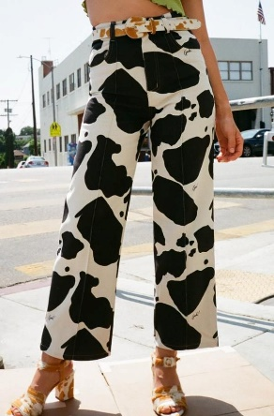
FAD: Patterned Pants
The fad in this example is the patterned pant that became popular during the pandemic. The pants are a bold way of drawing attention and can vary from the cow print (seen here) to prints depicting flowers. I personally don’t think this style will last because of how outgoing it is. They came from a time that we were cooped up and wanted an extreme change but now that were more settled post-pandemic, fashion will swing to being more lowkey and sophisticated.

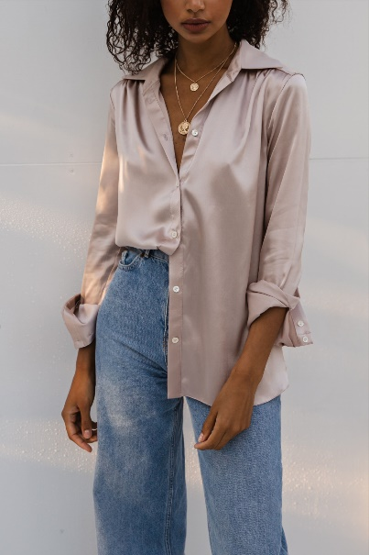
CLASSIC: Button down shirt
The classic button-down collared shirt is something that is in everyone’s closet. Originating in the late 1800, the shirt was worn by polo players. (They were even called ‘polo collar’ shirts.) Soon the style made its way to the public thanks to John Brooks who used his stores to distribute the shirt. The shirt was a staple for working men’s attire until the Italians used it as a casual style of dress in the mid-1900’s. Today, the button down is everywhere, and not just in men’s clothing. They vary in materials, style and prints.
Sources: https://hespokestyle.com/history-of-mens-button-down-shirts/

